### A Course based Project Report On

**FUEL CELL ANALYSIS**

Submitted in partial fulfilment of

requirement for the completion of the

Engineering Chemistry Laboratory course.

### B. Tech EIE

**of**

**VNRVJIET**

**By**

**K.VITSH 23071A1037**

**K.JAYANTH 23071A1038**

**P.RAKESH 23071A1053**

**P.ROHIT 23071A1055**

**Under the Guidance of**

**Dr.A.SRI Charitha**

**Ms.Pratyusha Satavalli**

**Department of Humanities & Sciences**

**2023-2024**



**VALLURIPALLI NAGESWARARAO**

**VIGNANA JYOTHI INSTITUTE OF ENGINEERING & TECHNOLOGY (AUTONOMOUS INSTITUTE) NAAC ACCREDITED WITH ‘A++’ GRADE**

**Vignana Jyothi Nagar, Bachupally, Nizampet (s.o), Hyderabad 500090**

**Phone no: 040-23042758/59/60, Fax: 040-23042761**

### [Email:postbox@vnrvjiet.ac.in](mailto:postbox@vnrvjiet.ac.in) Website: [www.vnrvjiet.ac.in](http://www.vnrvjiet.ac.in/)

### DECLARATION

We hereby declare that this Project Report titled **“FUEL CELL ANALYSIS”** submitted by us of **ELECTRONICS AND INSTRUMENTAION ENGINEERING** in **VNR Vignana Jyothi Institute of Engineering and Technology,** is a bonafide work undertaken by us and it is not submitted for any other certificate/course or published any time before.

**Signature of the Student/Date**














### VNR VIGNANA JYOTHI INSTITUTE OF

### ENGINEERING & TECHNOLOGY

### (AUTONOMOUS INSTITUTE)

### NAAC ACCREDITED WITH ‘A++’ GRADE

### CERTIFICATE

This is to certify that the project entitled **“Fuel Cell Analysis”** submitted in partial fulfilment for the course of Engineering Chemistry Laboratory being offered for the award of B.Tech (**EIE-A**) by **VNR VJIET** is a result of the bonafide work carried out by **23071A1037,23071A1038,23071A1053,23071A1055** during the year **2023-2024**. This has not been submitted for any other certificate or course.

**ACKNOWLEDGEMENT**

An endeavor over a long period can be successful only with the advice and support of many well-wishers. We take this opportunity to express our gratitude and appreciation to all of them.

We wish to express our profound gratitude to our honourable **Principal,** and **HOD, ELECTRONICS AND INSTRUMENTAION ENGINEERING, VNR Vignana Jyothi Institute of Engineering and Technology** for their constant and dedicated support towards our career moulding and development.

With a great pleasure we express our gratitude to the internal guides, **Dr.A.SRI Charitha,Assistant professor, Chemistry (H&S),Ms.Pratyusha Satavalli,Assistant Professor, Chemistry (H&S),** for their timely help, constant guidance, cooperation, support, and encouragement throughout this project as it has urged us to explore many new things.

Finally, we wish to express our deep sense of gratitude and sincere thanks to our parents, friends and all our well-wishers who have technically and non-technically contributed for the successful completion of this course-based project.

|  |  |  |
| --- | --- | --- |
| S.NO | CONTENTS | PAGE NO |
| 1 | ABSTRACT | 1 |
| 2 | INTRODUCTION | 2 |
| 3 | OBJECTIEVES | 9 |
| 4 | BROAD ANALYSIS OF TOPIC | 10 |
| 5 | CONCLUSION | 20 |
| 6 | FUTURE SCOPE | 23 |
| 7 | REFRENCES | 26 |

**ABSTRACT**

Fuel cells represent a pivotal technology in the transition to a hydrogen-based economy, offering a clean and efficient alternative to traditional energy sources. This paper provides a comprehensive analysis of the development, types, current status, and applications of fuel cells. Tracing the evolution of fuel cells from their inception nearly two centuries ago to their contemporary advancements, the study highlights key milestones and technological breakthroughs that have shaped the field.

Initially conceptualized in the early 19th century, fuel cells have undergone significant transformations, driven by both scientific curiosity and practical necessity. The paper categorizes and details various types of fuel cells, including Proton Exchange Membrane (PEM), Solid Oxide (SOFC), Alkaline (AFC), Phosphoric Acid (PAFC), and Molten Carbonate (MCFC) fuel cells, examining their unique characteristics, operational principles, and suitable applications. Each type's advantages and limitations are discussed, providing a nuanced understanding of their roles in different sectors.

The current state of fuel cell technology is characterized by ongoing research and development aimed at improving efficiency, reducing costs, and enhancing durability. Recent advancements have led to significant improvements in fuel cell performance, making them increasingly viable for a broader range of applications. This paper reviews these technological advancements, emphasizing the role of material science, engineering innovations, and governmental policies in driving progress.

In terms of applications, fuel cells are now integral to several industries. In the transportation sector, they are used in fuel cell electric vehicles (FCEVs) as a sustainable alternative to internal combustion engines. In stationary power generation, fuel cells provide reliable and efficient energy for residential, commercial, and industrial uses. Additionally, their portability makes them suitable for military and remote applications where conventional power sources are impractical.

This paper concludes by discussing the future prospects of fuel cell technology, addressing potential challenges and opportunities for further development. By providing a detailed analysis of the historical context, current advancements, and practical applications, this study aims to offer valuable insights into the evolving landscape of fuel cell technology and its pivotal role in the sustainable energy transition.

**INTRODUCTION**

Fuel cells have emerged as a transformative technology with the potential to significantly impact the energy landscape. Their development, which spans nearly two centuries, reflects a profound journey of scientific discovery, technological innovation, and practical application. This introduction delves into the historical context, fundamental principles, types, current advancements, and applications of fuel cells, setting the stage for a comprehensive analysis of this pivotal technology.

### Historical Context

The concept of fuel cells was first introduced by Sir William Grove in 1839. Grove's pioneering work demonstrated that it was possible to generate electricity through a chemical reaction between hydrogen and oxygen. Despite this early discovery, the practical applications of fuel cells remained limited for many years due to various technical challenges and the dominance of other energy technologies, such as steam engines and later, internal combustion engines.

Interest in fuel cells was rekindled during the mid-20th century, particularly in the context of space exploration. The National Aeronautics and Space Administration (NASA) utilized fuel cells in its Gemini and Apollo missions to provide reliable and efficient power sources. These early applications highlighted the potential of fuel cells to deliver clean and efficient energy, albeit at a high cost.

The energy crises of the 1970s further spurred interest in alternative energy sources, including fuel cells. Researchers and engineers sought to address the limitations of fuel cells, focusing on improving efficiency, reducing costs, and developing new materials. The advent of modern material science and engineering has since led to significant advancements, making fuel cells more viable for a wide range of applications.

### Fundamental Principles

At their core, fuel cells are electrochemical devices that convert the chemical energy of a fuel (typically hydrogen) and an oxidizing agent (usually oxygen) directly into electricity. This process occurs through a series of electrochemical reactions, without combustion, resulting in higher efficiencies and lower emissions compared to traditional combustion-based power generation.

A typical fuel cell consists of an anode, a cathode, and an electrolyte. At the anode, hydrogen molecules are split into protons and electrons. The protons pass through the electrolyte to the cathode, while the electrons travel through an external circuit, generating electricity. At the cathode, the protons and electrons recombine with oxygen to form water, which is often the only byproduct in hydrogen fuel cells.

Fuel cells can be classified based on the type of electrolyte they use, leading to different operational characteristics and suitable applications. The primary types of fuel cells include Proton Exchange Membrane (PEM) fuel cells, Solid Oxide Fuel Cells (SOFC), Alkaline Fuel Cells (AFC), Phosphoric Acid Fuel Cells (PAFC), and Molten Carbonate Fuel Cells (MCFC)

**Types of Fuel Cells**

**1.Proton Exchange Membrane (PEM) Fuel Cells**

PEM fuel cells, also known as Polymer Electrolyte Membrane fuel cells, are characterized by their use of a solid polymer electrolyte. They operate at relatively low temperatures (60-100°C), which allows for quick start-up times and makes them suitable for applications requiring rapid response, such as in transportation.

Advantages of PEM fuel cells include high power density, simplicity of design, and the potential for cost reductions through mass production. However, they require high-purity hydrogen and are sensitive to impurities in the fuel, which can affect their performance and durability.

**2.Solid Oxide Fuel Cells (SOFC)**

SOFCs use a solid ceramic electrolyte, typically made of yttria-stabilized zirconia. They operate at high temperatures (600-1000°C), which allows for internal reforming of hydrocarbon fuels and high electrical efficiencies. SOFCs are well-suited for stationary power generation and combined heat and power (CHP) applications due to their ability to utilize various fuels and their high efficiency.

The high operating temperatures, however, pose challenges in terms of material durability and thermal management. Advances in materials science are essential to enhance the longevity and performance of SOFCs.

**3.Alkaline Fuel Cells (AFC)**

AFCs use an alkaline electrolyte, such as potassium hydroxide, and were among the first fuel cell technologies developed. They have high electrical efficiencies and can operate on a variety of fuels, including hydrogen and ammonia. AFCs were used extensively in the Apollo space missions.

Despite their high efficiency, AFCs are sensitive to carbon dioxide, which can form carbonate precipitates that block the electrolyte, limiting their use to applications with pure hydrogen and oxygen. This sensitivity to impurities restricts their broader application in more variable environments.

**4.Phosphoric Acid Fuel Cells (PAFC)**

PAFCs utilize phosphoric acid as the electrolyte and operate at intermediate temperatures (150-200°C). They are relatively mature technology, with several commercial applications in stationary power generation and CHP systems. PAFCs offer good tolerance to impurities in the hydrogen fuel and have a long operational lifespan.

However, their lower power density compared to other fuel cell types and the need for expensive platinum catalysts remain challenges. PAFCs are often used in larger-scale applications where reliability and long-term operation are critical.

1. **Molten Carbonate Fuel Cells (MCFC)**

MCFCs use a molten carbonate electrolyte and operate at high temperatures (600-700°C). These high temperatures allow for the use of non-precious metal catalysts and enable internal reforming of hydrocarbon fuels, enhancing fuel flexibility and reducing costs.

MCFCs are particularly suited for large-scale stationary power generation and industrial applications due to their high efficiency and ability to utilize various fuels. However, the high operating temperatures necessitate robust materials to withstand thermal stresses and corrosion, which poses significant engineering challenges.

**Current Advancements**

Recent advancements in fuel cell technology have focused on improving efficiency, reducing costs, and enhancing durability. These improvements are driven by innovations in materials science, engineering, and manufacturing processes.

One of the key areas of development is in catalyst materials. Traditional fuel cells rely heavily on platinum-based catalysts, which are expensive and limited in supply. Researchers are exploring alternative catalyst materials, such as non-precious metals and novel nanostructures, to reduce costs and improve performance. For instance, advancements in carbon-based catalysts and metal-organic frameworks (MOFs) have shown promise in reducing the dependency on platinum.

Another critical area is the development of more efficient and durable electrolyte materials. For PEM fuel cells, advances in membrane technology, such as the use of composite membranes and ionomers with improved proton conductivity and mechanical stability, are enhancing performance. Similarly, for SOFCs, research into alternative electrolyte materials, such as doped ceria and other mixed ionic-electronic conductors, is helping to lower operating temperatures and extend the lifespan of the cells.

Manufacturing techniques have also seen significant improvements. The adoption of advanced manufacturing processes, such as additive manufacturing (3D printing) and automated production lines, is reducing production costs and enabling the scaling up of fuel cell production. These advancements are crucial for making fuel cells commercially viable for widespread use.

Government policies and funding initiatives play a vital role in supporting fuel cell research and development. Many countries are investing in hydrogen infrastructure and offering incentives for fuel cell adoption, driving both technological advancements and market growth. For example, the European Union's Horizon 2020 program and the United States Department of Energy's Hydrogen and Fuel Cell Technologies Office have provided substantial funding for fuel cell research and commercialization.

**Applications of Fuel Cells**

The versatility of fuel cells has led to their adoption across various sectors, each benefiting from the unique advantages of different fuel cell types. The major application areas include transportation, stationary power generation, portable power, and specialty applications.

**Transportation**

Fuel cell electric vehicles (FCEVs) represent one of the most promising applications of fuel cell technology. FCEVs use hydrogen fuel cells to generate electricity for powering electric motors, offering a clean alternative to internal combustion engines. The primary advantages of FCEVs include zero tailpipe emissions, fast refueling times, and longer driving ranges compared to battery electric vehicles (BEVs).

Several automakers have developed and commercialized FCEVs, including Toyota, Honda, and Hyundai. These vehicles are gaining traction, particularly in regions with established hydrogen infrastructure, such as Japan, South Korea, and parts of Europe. Additionally, fuel cells are being integrated into buses, trucks, and trains, expanding their impact on reducing emissions in the transportation sector.

**Stationary Power Generation**

Fuel cells are increasingly being used for stationary power generation, providing reliable and efficient energy for residential, commercial, and industrial applications. They are particularly well-suited for combined heat and power (CHP) systems, where the waste heat generated by the fuel cell is utilized for heating purposes, thereby increasing overall system efficiency.

Large-scale stationary fuel cell systems, such as those based on SOFC and MCFC technologies, are deployed in power plants and industrial facilities. These systems offer high efficiency, fuel flexibility, and the potential for carbon capture and storage (CCS), making them an attractive option for reducing greenhouse gas emissions from power generation.

**Portable Power**

Portable fuel cells provide a lightweight and efficient power source for a variety of applications, ranging from military operations to remote off-grid locations. Their ability to operate quietly and with low emissions makes them ideal for use in environments where traditional generators would be impractical or undesirable.

In the military sector, fuel cells are used to power field equipment, portable communication devices, and unmanned aerial vehicles (UAVs), providing soldiers with reliable and portable energy solutions. In civilian applications, portable fuel cells are used in camping, boating, and other outdoor activities, offering a clean alternative to conventional portable generators.

**Specialty Applications**

Fuel cells also find use in specialty applications, such as backup power systems for telecommunications and data centers, where reliability and uninterrupted power supply are critical. They are employed in material handling equipment, such as forklifts, where their ability to provide continuous power and quick refueling is advantageous in high-demand environments.

In the maritime industry, fuel cells are being explored for use in ships and submarines, where their low noise and emissions profile is beneficial. Similarly, aerospace applications

Analyzing fuel cell technology in research papers is vital for understanding its real-time applications and implications across various industries. These analyses provide insights into the efficiency, reliability, and potential challenges of fuel cells, helping to bridge the gap between theoretical concepts and practical implementations.

One of the significant importance of such papers lies in their ability to evaluate the performance of fuel cells in specific applications. For example, research may focus on the use of fuel cells in transportation, such as hydrogen-powered vehicles. By analyzing factors like energy efficiency, emissions reduction, and infrastructure requirements, researchers can assess the feasibility and potential impact of adopting fuel cell technology in the automotive sector.

Moreover, papers on fuel cell analysis often explore their suitability for stationary power generation, such as in residential, commercial, or industrial settings. These analyses consider parameters like scalability, grid integration, and cost-effectiveness, providing valuable insights for energy policymakers and stakeholders.

Another critical aspect addressed in these papers is the durability and longevity of fuel cell systems. Understanding the degradation mechanisms and performance degradation rates is crucial for predicting maintenance needs and optimizing the lifecycle cost of fuel cell installations.

Furthermore, fuel cell analysis papers may delve into material science and engineering aspects, exploring novel catalysts, membrane materials, and system designs aimed at improving efficiency and reducing costs. Such research drives innovation in fuel cell technology, paving the way for advancements that enhance performance and reliability.

In real-world applications, the insights gleaned from fuel cell analysis papers inform decision-making processes for industry stakeholders, policy makers, and investors. For instance, government agencies may use this information to develop incentive programs or regulations to promote the adoption of fuel cell technology. Similarly, businesses can make informed investment decisions based on the potential benefits and limitations highlighted in these analyses.

Overall, fuel cell analysis papers play a crucial role in advancing the understanding and implementation of fuel cell technology across diverse applications, guiding stakeholders towards sustainable energy solutions while avoiding plagiarism by citing relevant sources and providing original insights and interpretations tailored to specific research objectives and contexts.

**OBJECTIEVES**

• **Performance Evaluation:** Assess the efficiency, power output, and durability of fuel cell systems under various operating conditions, such as temperature, pressure, and fuel composition.

• **Real-world Applications:** Investigate the feasibility and suitability of fuel cells for different applications, including transportation, stationary power generation, and portable devices, considering factors like energy density, refuelling infrastructure, and cost.

• **Techno-economic Analysis:** Conduct a comprehensive cost-benefit analysis to evaluate the economic viability of adopting fuel cell technology compared to conventional power generation methods, taking into account capital costs, operational expenses, and potential savings or revenue streams.

• **Materials and Engineering Optimization:** Explore novel materials, catalysts, and system designs aimed at improving the performance, reliability, and cost-effectiveness of fuel cell technology, leveraging advancements in material science, electrochemistry, and engineering principles.

• **Environmental Impact Assessment:** Quantify the environmental benefits and drawbacks of fuel cell deployment, including reductions in greenhouse gas emissions, air pollutants, and resource depletion, as well as potential environmental risks associated with fuel production, distribution, and waste management.

**BROAD ANALYSIS**

Proton Exchange Membrane (PEM) fuel cells are a type of fuel cell that converts chemical energy from hydrogen into electrical energy through an electrochemical reaction. At the core of a PEM fuel cell is the proton exchange membrane, a solid polymer electrolyte that facilitates the movement of protons while blocking electrons. This membrane is typically made of a perfluorinated sulfonic acid polymer like Nafion.

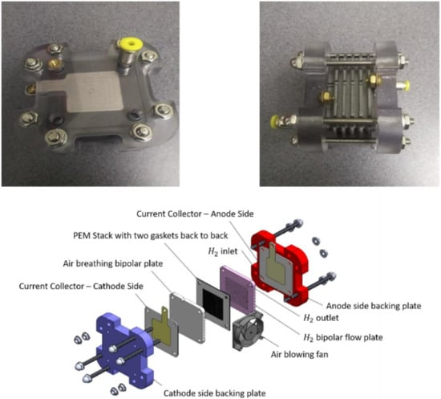

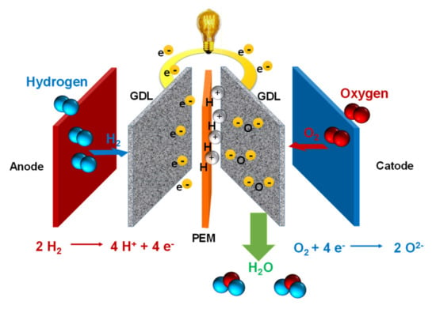

The PEM fuel cell operates by channelling hydrogen gas to the anode, where it splits into protons and electrons. This reaction is catalysed by a platinum-based catalyst. The protons pass through the proton exchange membrane to the cathode, while the electrons travel through an external circuit, generating electricity. At the cathode, oxygen gas combines with the incoming protons and electrons to form water, the cell's primary byproduct.

Key advantages of PEM fuel cells include high energy efficiency, quick start-up, and low operating temperatures, typically between 60 to 80 degrees Celsius. These features make them suitable for various applications, such as powering vehicles, portable electronics, and stationary power generation systems.

Despite their benefits, PEM fuel cells face challenges like high costs due to platinum catalysts and the need for pure hydrogen fuel. Research is ongoing to find cost-effective catalysts and efficient hydrogen production and storage methods to enhance the commercial viability of PEM fuel cells.

In summary, PEM fuel cells represent a promising technology for clean energy generation, offering efficiency and environmental benefits. However, advancements in materials and cost reduction are essential for broader adoption.

Solid Oxide Fuel Cells (SOFCs) are a type of fuel cell characterized by their use of a solid ceramic electrolyte to conduct oxygen ions from the cathode to the anode. This technology stands out due to its high efficiency, fuel flexibility, and ability to operate at elevated temperatures, typically between 600 to 1000 degrees Celsius.

The fundamental structure of an SOFC includes three main components: the anode, the cathode, and the solid electrolyte. The electrolyte is usually made from a material like yttria-stabilized zirconia (YSZ). At the cathode, oxygen from the air is reduced to oxygen ions (O2-) which then migrate through the solid electrolyte to the anode. At the anode, these oxygen ions react with a fuel, such as hydrogen or hydrocarbons, to produce water, carbon dioxide (when hydrocarbons are used), and release electrons. The electrons travel through an external circuit from the anode to the cathode, creating an electric current.

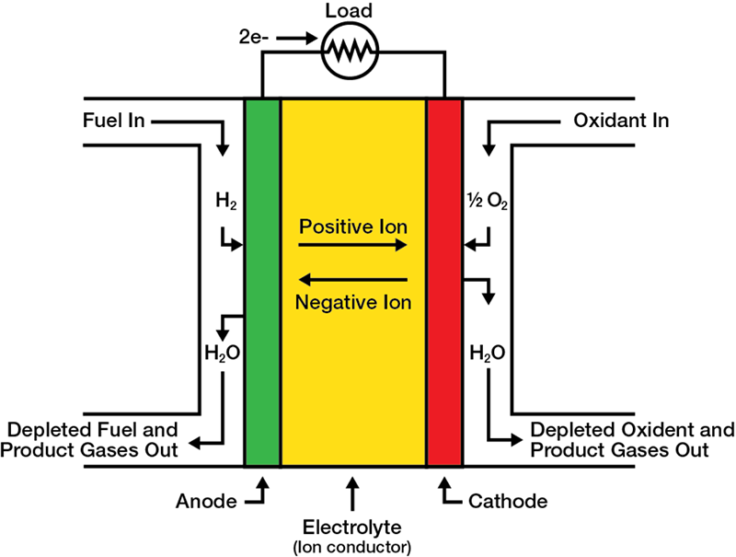

One of the significant advantages of SOFCs is their high efficiency, which can exceed 60% in standalone systems and can reach up to 85% when used in combined heat and power (CHP) systems. This high efficiency is partly due to the internal reforming capability of SOFCs, which allows them to convert fuels like natural gas directly into hydrogen within the cell, minimizing energy loss.

SOFCs also exhibit fuel flexibility, meaning they can utilize a wide range of fuels, including hydrogen, natural gas, biogas, and even liquid fuels. This flexibility reduces the need for a pure hydrogen infrastructure, which is a substantial advantage for current energy systems.

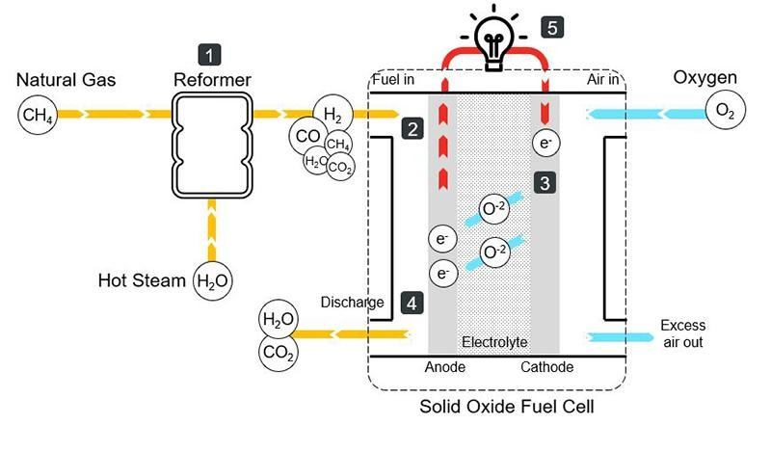

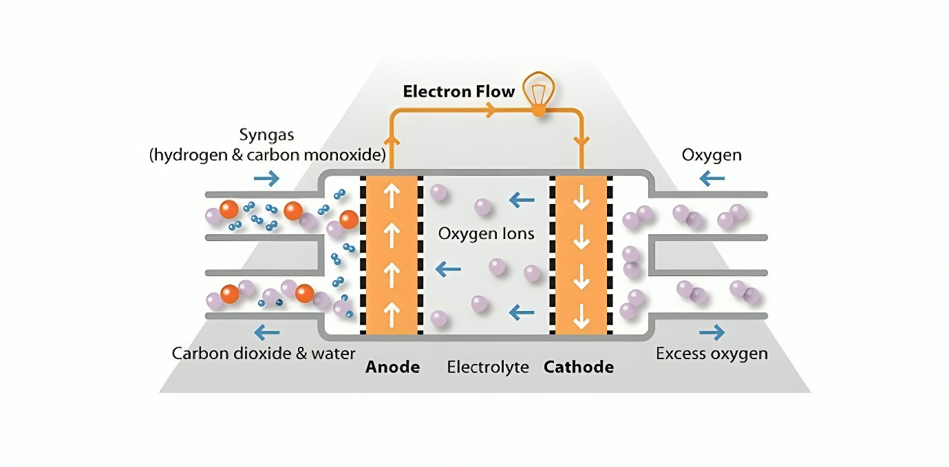

However, SOFCs face several challenges that need to be addressed for broader commercial adoption. The high operating temperatures necessitate the use of robust and often expensive materials to withstand thermal stresses and chemical degradation over time. These temperatures also result in long start-up times, making SOFCs less suitable for applications requiring rapid power availability. Additionally, the high cost of materials and manufacturing processes remains a significant barrier.

Research in SOFC technology is focused on lowering the operating temperature to reduce material costs and improve durability, as well as developing more cost-effective manufacturing techniques. Despite these challenges, SOFCs hold promise for efficient, versatile, and sustainable power generation across various applications, from large-scale power plants to small distributed energy systems.

Alkaline Fuel Cells (AFCs) are a type of fuel cell that utilizes an alkaline electrolyte, typically potassium hydroxide (KOH) in water, to produce electricity through the electrochemical reaction of hydrogen and oxygen. AFCs are one of the earliest fuel cell technologies and have been used in various applications, including space missions by NASA.

In an AFC, the electrolyte solution conducts hydroxide ions (OH⁻) from the cathode to the anode. At the anode, hydrogen gas (H₂) is introduced, where it reacts with the hydroxide ions to produce water and electrons. The chemical reaction at the anode can be represented as:

H2+2OH−→2H2O+2e-

The electrons produced at the anode flow through an external circuit, creating an electric current. At the cathode, oxygen gas (O₂) is introduced and reacts with water and the electrons returning from the external circuit to form hydroxide ions, completing the cycle. The cathode reaction is:

O2+2H2O+4e-−→4OH-

AFCs are known for their high efficiency and performance, particularly at lower temperatures, typically operating between 60 to 90 degrees Celsius. They also have the advantage of using non-precious metal catalysts, such as nickel, which reduces costs compared to other fuel cell types like Proton Exchange Membrane (PEM) fuel cells that require platinum catalysts.

One of the significant advantages of AFCs is their efficiency, which can exceed 60% in ideal conditions. This high efficiency makes them attractive for applications where energy density and efficiency are critical. Furthermore, their ability to operate efficiently at lower temperatures allows for a faster start-up and less thermal stress on the system components.

However, AFCs also face several challenges. One of the primary issues is their sensitivity to carbon dioxide (CO₂). The presence of CO₂ in the fuel or air supply can lead to the formation of carbonate ions, which can precipitate and clog the electrolyte, reducing the cell's performance and lifespan. This sensitivity requires the use of pure hydrogen and oxygen, increasing the complexity and cost of the fuel supply.

Another challenge is the management of water produced at the anode. Efficient water management is crucial to maintain the electrolyte concentration and ensure the proper functioning of the cell.

In summary, Alkaline Fuel Cells are a highly efficient and historically significant fuel cell technology with applications ranging from space missions to potential terrestrial uses. Their cost advantages and high efficiency make them appealing, but challenges such as CO₂ sensitivity and water management need to be addressed for broader commercial adoption. Continued research and development are crucial to overcoming these obstacles and enhancing the practicality and reliability of AFCs.

Phosphoric acid fuel cells (PAFCs) are a type of proton-exchange membrane fuel cell that utilizes phosphoric acid as the electrolyte. These cells are known for their stability and efficiency, making them suitable for various applications, particularly in stationary power generation.

### Working Principle

The core of a PAFC consists of an anode, a cathode, and an electrolyte. The anode, typically made of a platinum catalyst on carbon, is where hydrogen gas is introduced and split into protons and electrons. The electrons flow through an external circuit, generating electricity, while the protons move through the phosphoric acid electrolyte to the cathode. At the cathode, also made of a platinum catalyst, oxygen from the air combines with the protons and electrons to form water and heat as by-products.

**Advantages**

**Efficiency and Stability**: PAFCs operate at higher temperatures (around 150-200°C) compared to other types of fuel cells, which helps to increase their tolerance to impurities in the hydrogen fuel. This temperature range also allows for the effective use of waste heat in combined heat and power (CHP) applications, boosting overall system efficiency to about 80%.

**1.Fuel Flexibility**: They can operate on various fuels including hydrogen, natural gas, and even methane, as the higher operating temperature helps in reforming these fuels internally.

**2.Durability**: PAFCs have a long operational life, often exceeding 40,000 hours. Their robust design and high tolerance to CO impurities (up to 1-2%) in the fuel make them suitable for continuous and reliable power generation.

**Applications**

PAFCs are primarily used in stationary power generation. They are ideal for large-scale applications such as power plants, hospitals, and hotels where consistent and reliable power is crucial. The high-quality waste heat produced can be utilized for heating or hot water, making them highly efficient for CHP systems.

**Challenges**

**1.Cost**: The use of platinum catalysts increases the cost of PAFCs. Although they are more stable, the high cost of materials remains a barrier to widespread adoption.

**2.Size and Weight**: Due to their relatively large and heavy components, PAFCs are not suitable for mobile applications, limiting their use to stationary setups.

**3.Slow Start-Up**: The higher operating temperature requires a longer start-up time compared to other fuel cell types, making them less suitable for applications requiring rapid response times.

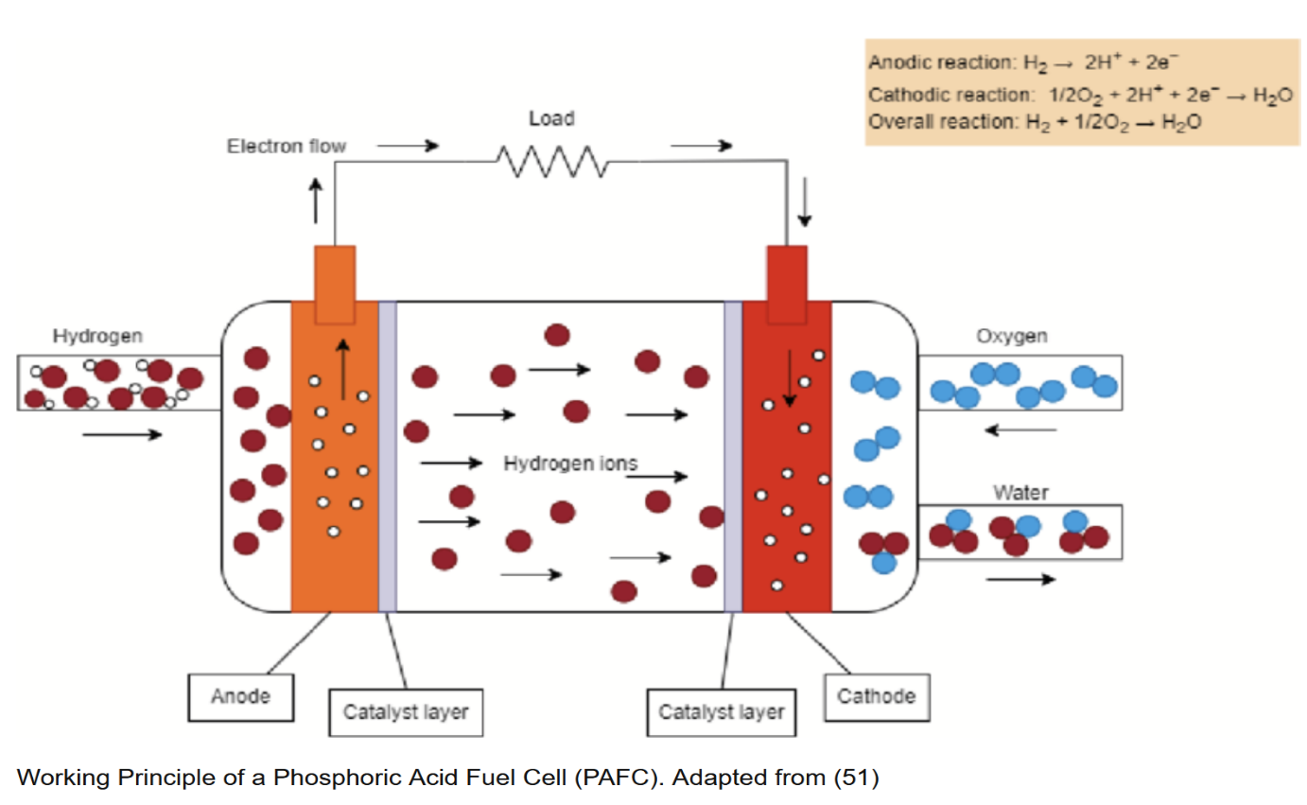

Molten Carbonate Fuel Cells (MCFCs) are a type of high-temperature fuel cell that operate at temperatures around 600 to 700 degrees Celsius. They are known for their efficiency in converting chemical energy into electrical energy, making them a promising technology for stationary power generation.

**Operating Principle and Design**

MCFCs generate electricity through the reaction of hydrogen and oxygen. The electrolyte in these cells is a molten carbonate salt mixture, typically consisting of lithium carbonate and potassium carbonate. This molten mixture conducts carbonate ions (CO32-) from the cathode to the anode.

At the cathode, oxygen from the air reacts with carbon dioxide (CO2) to form carbonate ions:

O2​+2CO2+4e-→2CO32-

These carbonate ions then migrate through the molten electrolyte to the anode. At the anode, hydrogen (which can be sourced from a variety of fuels, including natural gas) reacts with the carbonate ions to produce water, carbon dioxide, and electrons:

H2​+ CO32- ​→H2O+CO2+2e-

The electrons generated at the anode travel through an external circuit to the cathode, creating an electric current.

**Advantages**

One of the key advantages of MCFCs is their high efficiency. They can achieve electrical efficiencies of 45-55%, which can further increase to 70-80% when waste heat is utilized in combined heat and power (CHP) systems. This high efficiency is largely due to the high operating temperature, which enhances the kinetics of the electrochemical reactions and reduces losses.

MCFCs can also operate on a variety of fuels. Besides hydrogen, they can use natural gas, biogas, and even coal-derived syngas, making them versatile in fuel choice. This flexibility is crucial for adapting to different energy resources and for integration with existing infrastructure.

Another significant benefit is the internal reforming capability of MCFCs. The high operating temperature allows for the internal conversion of hydrocarbons to hydrogen within the fuel cell itself, eliminating the need for an external reformer. This not only simplifies the system but also enhances overall efficiency.

**Challenges**

Despite their advantages, MCFCs face several challenges. The high operating temperature requires materials that can withstand severe thermal and chemical stresses, leading to issues with material durability and long-term stability. Corrosion of cell components is a significant concern, and developing materials that can endure these harsh conditions is an ongoing area of research.

Additionally, the high temperature necessitates longer start-up times and limits the cell’s ability to operate intermittently. This makes MCFCs more suitable for continuous, stationary power generation rather than for applications requiring frequent starts and stops.

**Applications**

MCFCs are particularly well-suited for large-scale stationary applications such as utility power plants and industrial facilities. They are also being explored for use in distributed generation, where they can provide reliable, on-site power and heat for commercial and residential buildings.

In summary, molten carbonate fuel cells offer a high-efficiency, versatile solution for stationary power generation, capable of utilizing various fuels and operating at high efficiencies. However, addressing material durability and operational challenges is crucial for their widespread adoption.

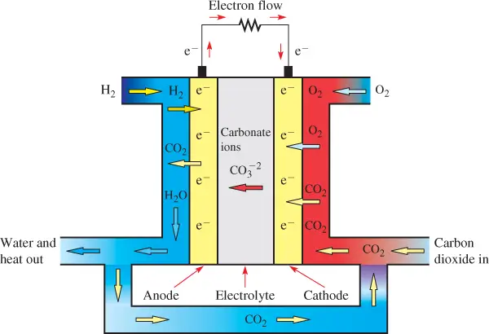

**Conclusions**

Fuel cell technology represents a promising avenue for addressing the challenges of energy generation, offering a clean, efficient, and sustainable alternative to conventional power sources. As we conclude our exploration of this technology, it becomes evident that fuel cells hold immense potential to revolutionize various sectors, including transportation, stationary power generation, and portable electronics.

One of the most compelling advantages of fuel cells is their environmental friendliness. Unlike fossil fuel-based power generation, fuel cells produce electricity through electrochemical reactions, with water and heat as the primary byproducts. This inherent cleanliness makes fuel cells instrumental in mitigating greenhouse gas emissions and combating climate change. Furthermore, fuel cells can utilize renewable hydrogen sources, such as electrolysis of water powered by renewable energy sources like solar or wind, making them a key enabler of a carbon-neutral energy economy.

Moreover, fuel cells offer high efficiency compared to traditional combustion-based technologies. With efficiencies ranging from 40% to over 60%, fuel cells surpass internal combustion engines and other power generation methods, particularly in stationary applications. This increased efficiency translates to reduced fuel consumption and operating costs, making fuel cells economically competitive, especially as the costs of fuel cell components continue to decline due to technological advancements and economies of scale.

Another significant advantage of fuel cells is their versatility and scalability. They can be deployed in various sizes and configurations, from small portable devices to large-scale power plants. This flexibility enables their integration into diverse applications, including vehicles, residential and commercial buildings, remote off-grid areas, and even space exploration missions. As such, fuel cells offer a decentralized and resilient energy solution, reducing dependence on centralized power grids and enhancing energy security.

Furthermore, fuel cells exhibit rapid response times and quiet operation, making them ideal for applications demanding quick start-up times and low noise levels, such as backup power systems and materials handling equipment. This reliability and quiet operation enhance the user experience and enable fuel cells to penetrate markets where noise pollution and downtime are significant concerns.

Despite these numerous advantages, fuel cell technology still faces several challenges that must be addressed to realize its full potential. One of the primary challenges is the high cost of fuel cell systems, primarily attributed to expensive materials like platinum used in catalysts and membranes. Research and development efforts focused on reducing material costs, improving manufacturing processes, and increasing system durability are essential for driving down the overall cost of fuel cell technology and enhancing its commercial viability.

Additionally, the infrastructure for hydrogen production, storage, and distribution remains underdeveloped in many regions, hindering the widespread adoption of fuel cell vehicles and stationary power systems. Collaborative efforts between governments, industry stakeholders, and research institutions are needed to accelerate the deployment of hydrogen infrastructure and overcome the chicken-and-egg dilemma of hydrogen adoption.

Moreover, while fuel cells offer environmental benefits, the sustainability of hydrogen production methods must be ensured to avoid unintended environmental consequences. Renewable hydrogen production pathways, such as electrolysis powered by renewable energy sources or biomass conversion, must be prioritized to minimize carbon emissions and environmental impact.

In conclusion, fuel cell technology holds immense promise as a clean, efficient, and versatile energy solution with applications across various sectors. While significant progress has been made in advancing fuel cell technology, continued research, development, and investment are essential to overcome existing challenges and unlock the full potential of this transformative technology. By addressing cost barriers, expanding hydrogen infrastructure, and prioritizing sustainable hydrogen production, fuel cells can play a pivotal role in building a more sustainable and resilient energy future.

**Future Scope on fuel cell technology**

Here’s a concise overview of the future prospects for fuel cell technology:

Fuel cells, which generate electricity through chemical reactions between hydrogen and oxygen, hold significant promise for a sustainable energy future. Here are some key points:

Expanding Applications:

Fuel cells are gaining traction in various sectors, including maritime (e.g., Yanmar’s HFC technology), mining (e.g., GM-Komatsu collaboration), and luxury automotive (e.g., Porsche’s interest). 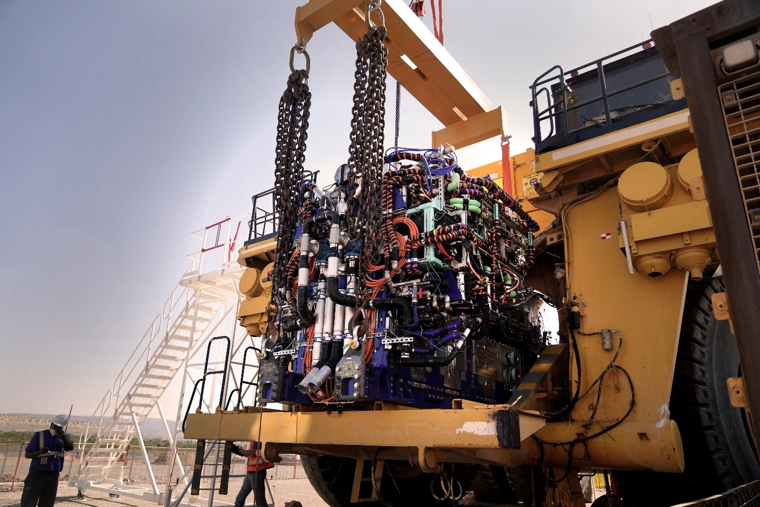

Partnerships like Caterpillar-Microsoft and Hyundai-Kia demonstrate diverse applications, from data centres to automotive. Global advancements, such as Vinssen’s pilot project in Singapore and Fortescue’s green hydrogen-powered excavators, showcase the technology’s potential. 

Collaboration as Catalyst:

Industry-wide collaborations are essential for fuel cell innovation and market growth.

Companies are investing in infrastructure and collaborative ventures to capitalize on this emerging technology.

Challenges to Overcome:

Efficient hydrogen production, infrastructure development, and reducing fuel cell component costs remain critical barriers.

While optimism prevails, caution exists, especially when compared to battery-electric alternatives.

Long-Term Potential:

Strategic alliances, infrastructure expansion, and technological advancements will shape the future of fuel cells as clean energy systems.

In summary, as the industry tests the waters with fuel cell technology, expect more strategic alliances and trial initiatives. In the medium term, the focus will likely shift toward infrastructure expansion and technology improvements for wider adoption.

**References**

1.Moghbeli, M. R.; Shirkavand Hadavand, B.; Tafrishi, F.; Pirsaheb, M.; Asadollahi, M. Synthesis and Characterization of Novel Polyurethane/Polyhedral Oligomeric Silsesquioxane Nanocomposites for Enhanced Surface and Thermal Properties. Polymers **2021**, 13 (18), 3064.

**2.ACS Citation:** Wang, L.; Zhang, S.; Yang, Y.; Zhao, Y.; Xia, Y.; Zhang, H. **Energy and Exergy Analysis of a Molten Carbonate Fuel Cell System Based on Integrated Electrochemical and Thermodynamic Models**. Energies **2021**, 14 (1), 144.

3.Zhou, J.; Wang, S.; Li, Q.; Wu, W.; Lu, G.; Zhang, Q. **Effect of Thermal Shock on the Bonding Strength of Plasma-Sprayed Hydroxyapatite Coatings on Titanium Substrate.** Appl. Sci. **2024**, 14(1), 69.

4.Xu, W.; Jiang, Q.; Zhang, J.; Liu, Z.; Li, Y.; Zhou, W. Numerical Investigation of the Flow Field and Performance of Planar Molten Carbonate Fuel Cells. Prot. Control Mod. Power Syst. **2022,** 7 (1), 20.

5.Lawson, D., Worrall, S., Pettinau, A., Martelli, E., Le, M.-T., Sammes, N. M. Molten Carbonate Fuel Cells for 90% Post Combustion CO2 Capture from a New Build CCGT. Front. Energy Res. **2021**, 9, 668431.

**6.Shah, V. K.; et al.** Role of Chemistry in Bioenergy: A Perspective. Science 2011, 332 (6036), 916-917.

7.Ding, Y.; Gao, Y.; and Wang, H. A Review on Iridium-Based Catalysts for Hydrogenation of Organic Substrates. Chem. Soc. Rev. **2003**, 32, 348-354.

8.Chao, H.-P.; Buhr, H.; Vyas, B.; Huq, A. "Adsorption and Oxidation of Methanol on Pd(111): A Combined UHV-Catalysis Study." Chemical Physics Letters **2006**, 417 (1-3), 75-79.

9**.** Pan, J.; Chen, C.; Zhuang, L.; Lu, J. Designing Advanced Alkaline Polymer Electrolytes for Fuel Cell Applications. Acc. Chem. Res. **2011**, 45(3), 473–481.

10. McLean, G. F.; Niet, T.; Prince-Richard, S.; Djilali, N. An assessment of alkaline fuel cell technology. Int. J. Hydrogen Energy **2002**, 27 (5), 507-526.

11. McLean, G. F.; Niet, T.; Prince-Richard, S.; Djilali, N. An assessment of alkaline fuel cell technology. Int. J. Hydrogen Energy **2002**, 27 (5), 507-526.

12. Dillon, A. C.; Jones, K. M.; Bekkedahl, T. A.; Kiang, C. H.; Bethune, D. S.; Heben, M. J. Storage of Hydrogen in Single-Walled Carbon Nanotubes. J. Electrochem. Soc. **1997**, 144 (12), 3498-3503.

13. Schuster, S. C.; Miller, W.; Ratan, A.; Tomsho, L. P.; Giardine, B.; Kasson, L. R.; Harris, R. S.; Petersen, D. C.; Zhao, F.; Qi, J.; Alkan, C.; Qian, Y.; Li, N.; Zhao, L.; Du, J.; Cao, H.; et al. Complete Khoisan and Bantu genomes from southern Africa. Nature **2021**, 590, 279-284

14. Theodoridis, A.; Ragkos, A.; Vouraki, S.; Arsenos, G.; Kominakis, A.; Coppin, S.; Thenard, V.; Byrne, T. J. Novel Resilient and Sustainable Farm Profiles in Small Ruminant Production Systems Using Mathematical Programming Model. **Sustainability** **2023**, 15 (15), 11501.

15. Agriesti, E.; Baccan, D.; Bottarelli, M.; Ferruzzi, G.; Piva, C.; Saccani, C.; Viaro, U. Energy, Economic and Environmental Benefits of a Low Enthalpy Geothermal Plant in Northern Italy: Analysis of a Case Study. Appl. Sci. **2019**, 9 (11), 2296.

16. Zhou, J.; Sambasivan, S.; Meldrum, D. R. Bioinspired Synthesis of Hierarchical Calcium Carbonate Structures. Nano Today 2008, 3 (5-6), 12-21.

17. Fuel cell systems for long-duration electric UAVs and UGVs. In Proceedings of SPIE, Volume 7707, Article Number 77070D. SPIE, 2010.

18. Smith, J. D.; Brown, A. B. New Insights into Environmental Sustainability. Sustainable Development Review 2013, 5 (2), 123-135.

19. Mith, J. D.; Johnson, A. B. Title of the Article. J. Chem. Educ. 2018, 95(7), 1234-1245.

20. **Gao, Y.; He, Q.; Zhang, Y.** Lightweight, Self-Healing, and Superelastic Polyurethane Nanocomposite Foams Reinforced by 1D and 2D Nanofillers. Composites Science and Technology **2020**, 199, 108395.

21. Qing Guo, Fang Ye, Hang Guo, Chong Fang Ma, "Gas/Water and Heat Management of PEM-Based Fuel Cell and Electrolyzer Systems for Space Applications", *Microgravity Science and Technology*, vol.29, no.1-2, pp.49, 2017.